Teacher Preparation Notes for
“Food Webs – Understanding What Happened When Wolves Returned to Yellowstone”

To begin, students view a video about ecosystem changes that resulted when wolves were reintroduced to Yellowstone. Next, students learn about food chains and food webs. They construct and analyze a food web for Yellowstone National Park. Finally, students use what they have learned to understand a trophic cascade caused by the return of wolves to Yellowstone.

This activity can be used for classroom instruction or remote learning. For classroom instruction, you can either supply the decks of organism cards (see pages 2-3 of these Teacher Preparation Notes) or have students cut the cards from copies of pages 5-7 of the Student Handout. For remote learning, we suggest that you use one of the following options:
- If your students have printers at home, they can print pages 5-7 of the Student Handout and cut the cards.
- If your students do not have printers, you can use either of the following options.
  - Set up a Jamboard for your students to use in the format shown on the next-to-the-last page of these Teacher Preparation Notes. You can make a copy of the Jamboard at https://jamboard.google.com/d/1A-c18IR0LkGl-wa_yP_FhrA-mOBXvrIY-RsDpizJG58/copy.
  - Use the “remote no printer” version of the Student Handout available at https://serendipstudio.org/exchange/bioactivities/foodwebRR.

This learning activity provides an introduction to the learning activities, Carbon Cycles and Energy Flow through Ecosystems and Trophic Pyramids. All three of these activities are included in Food Webs, Energy Flow, Carbon Cycle and Trophic Pyramids, which is intended for classroom instruction.

Learning Goals
Learning Goals related to Next Generation Science Standards
Students will gain understanding of Disciplinary Core Ideas
- LS2.B, Cycles of Matter and Energy Transfer in Ecosystems: “Food webs are models that demonstrate how matter and energy is transferred between producers, consumers and decomposers as the three groups interact within an ecosystem.”
- LS2.C, Ecosystem Dynamics, Functioning, and Resilience: “A complex set of interactions within an ecosystem can keep its numbers and types of organisms relatively constant over long periods of time under stable conditions.… Extreme fluctuations in conditions or the size of any population, however, can challenge the functioning of ecosystems in terms of resources and habitat availability.”

Students will engage in Scientific Practices:
- “Constructing Explanations – Apply scientific ideas, principles, and/or evidence to provide an explanation of phenomena…”
- “Developing and Using Models – Develop, revise, and/or use a model based on evidence to illustrate and/or predict the relationships between systems or between components of the system.”

This activity will help students understand the Crosscutting Concept, “Stability and Change: Much of science deals with constructing explanations of how things change and how they remain stable.”

This activity will help to prepare students for the Performance Expectation, HS-LS2-2. “Use mathematical representations to support and revise explanations based on evidence about factors affecting… populations in ecosystems of different scales.”

Specific Content Learning Goals
- A producer is an organism that produces all of its own organic molecules from small inorganic molecules. A consumer is an organism that consumes organic molecules produced by other organisms. Consumers can be categorized as primary consumers which eat producers, decomposers which consume dead organic matter, secondary consumers which consume primary consumers or decomposers, or trophic omnivores which consume organisms at more than one trophic level.
- In a trophic relationship one organism consumes organic molecules from another organism (or a decomposer consumes organic molecules from dead organic matter). A food chain shows a simple sequence of trophic relationships (e.g. producer → primary consumer → secondary consumer). A food web shows the multiple complex trophic relationships among organisms in an ecosystem.
- Decomposers are crucial to prevent excessive accumulation of dead organic matter.
- Understanding a food web can help us to understand how changes in the population size of one organism can influence the population size of another organism in an ecosystem. For example, a trophic cascade can occur when an increase in a predator population results in a decrease in an herbivore population which in turn results in increased growth of producers.
Supplies for your students to make the Yellowstone food web (if your students are doing the activity in your classroom)

For each group of 2-4 students:
- a deck of 18 cards for a partial Yellowstone food web (to be reused in each class, so you will need a deck of cards for each student group in your largest class)
- Pages 5-7 of the Student Handout have the images for these cards. We recommend that you print the cards on card stock and/or laminate these cards for durability. A PDF file suitable for professional printing and cutting of cards is available at https://serendipstudio.org/exchange/bioactivities/foodweb.
- Before you laminate the cards we recommend that you use markers to mark the edges of each deck with a different color stripe to help you keep track of which cards belong in which deck.
- a lab table or other surface ~1.5 feet wide by 2 feet tall (~45 x 60 cm) which students can write on with chalk or dry erase marker as they create their food web or a large piece of paper (e.g. from an easel pad) or poster board. If it is not feasible for you to provide such a large surface for students to write on, you can provide each group with a reusable card stock or poster board set of the rectangles described in the chart on the bottom of page 3 of the Student Handout; if you are using this approach, we recommend that you provide masking tape or thin strips of paper of varying length that students can use to draw arrows (one set of 27 for each student group in your largest class, plus a few extras in case some are damaged).
- if students are writing on lab tables, chalk or a dry erase marker to draw rectangles and arrows

Instructional Suggestions and Background Information
In the Student Handout, numbers in bold indicate questions for the students to answer and capital letters in bold indicate steps for students to do as they model the Yellowstone food web.

If your students are learning online, we recommend that they use the Google Doc version of the Student Handout available at https://serendipstudio.org/exchange/bioactivities/foodwebRR. To answer questions 4, 8, 9, and 12, students can either print the relevant pages, draw on those and send you pictures, or they will need to know how to modify a drawing online. They can double-click on the relevant drawing in the Google Doc, which will open a drawing window. Then, they can use the editing tools to add shapes and text boxes. You may want to revise the GoogleDoc or Word document to prepare a version of the Student Handout that will be more suitable for your students; if you do this, please check the format by viewing the PDF.

To maximize student learning, we recommend that you have your students work in pairs, at least to answer question 9, construct the Yellowstone food web, and answer questions 10-13 (or 10-12 for the no printer version). After students have worked together to make the food web or answer a group of related questions, we recommend having a class discussion that probes student thinking and helps students to develop a sound understanding of the concepts and information covered.

A key for this activity is available upon request to Ingrid Waldron (iwaldron@upenn.edu). The following paragraphs provide additional instructional suggestions and background biology information – some for inclusion in your class discussions and some to provide you with relevant background that may be useful for your understanding and/or for responding to student questions.

Wolves in Yellowstone National Park
The recommended part of the “Ecosystems Video” (https://www.learner.org/series/the-habitable-planet-a-systems-approach-to-environmental-science/ecosystems/ecosystems-video/) should engage student interest and introduce your students to the Yellowstone ecosystem. The part on Yellowstone begins at 13 minutes and 40 seconds. We recommend that you end at 22 minutes and 37 seconds, but obviously you could continue to the end if you think the additional complexities would be suitable for your students.

Yellowstone National Park includes ~3500 square miles, mainly in Wyoming. The park includes a variety of habitats, including forests, grasslands, and aquatic habitats. | 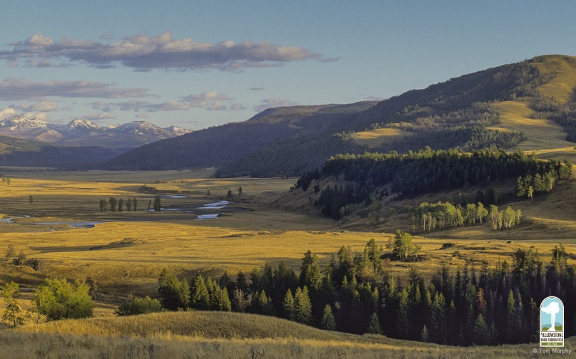

The graph on page 1 of the Student Handout shows trends in wolf and elk populations in the Northern Range of Yellowstone where many elk and wolves spend the winter. This graph shows trends in number of wolves for larger areas.  Wolf Population | 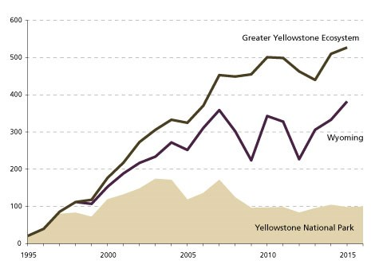  (https://www.nps.gov/yell/learn/nature/wolves.htm)

Questions 1-3 are intended to start students thinking about phenomena that will be revisited in the rest of the activity. As your students discuss their answers to these questions, you can guide them to ask questions and formulate hypotheses that will set the stage for later sections. For example, if your students respond to question 1b by saying that the wolves eat the dead elk, you can probe for additional ideas by asking whether they think wolves eat every part of the elks’ bodies.

Food Chains and Food Webs
For the discussion of food chains and food webs, your students should understand that the arrows point from the organism that is consumed to the organism that consumes. In other words, the arrows show the direction of flow of nutrition.

We use the term producer (but not the equivalent term autotroph) for organisms that use energy from sunlight to make all of their organic molecules. Producers include not only plants (which are mentioned in the Student Handout), but also other photosynthesizing organisms such as algae and cyanobacteria. We use the term consumer (but not the equivalent term heterotroph) for organisms that consume other organisms. If you want, you can easily include the terms autotroph and heterotroph.

Decomposers such as bacteria and fungi release enzymes into dead organic matter; these enzymes digest complex organic molecules into smaller soluble molecules that are absorbed by the decomposers. Detritivores such as earthworms and termites ingest dead organic matter, extract nutrition, and excrete smaller particles which decomposers can more readily digest. Other animals such as coyotes, bears, ravens, and eagles feed on carrion such as the remains of an elk killed by a wolf pack. An entertaining and informative brief video, “Dead Stuff: The Secret Ingredient in Our Food Chain” (https://www.youtube.com/watch?v=KI7u_pcfAQE), summarizes some of the information in this activity and introduces food chains and food webs. You may want to show this video after question 5.

If your students are not familiar with fungi, you may want to introduce them to the basic structure of an above ground fruiting body that produces spores (e.g. a mushroom), and the mycelium, a vast network of hyphae in the soil, rotting log, or other organic matter. The hyphae in the mycelium secrete digestive enzymes and absorb nutrients. | 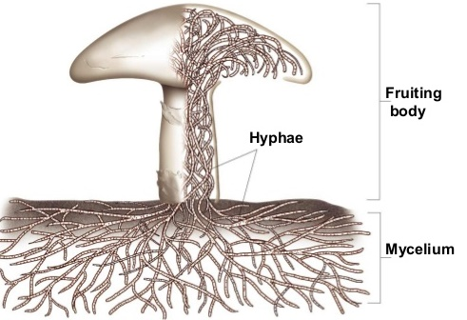
(http://image.slidesharecdn.com/funginotes-131009165742-phpapp02/95/fungi-notes-4-638.jpg?cb=1381337957)

The trophic omnivore category includes the more familiar category of omnivores (animals that eat both plants and animals). However, the trophic omnivore category also includes other organisms that consume organisms at more than one trophic level (e.g., carnivores like the Yellowstone wolves that eat both primary and secondary consumers). An animal that eats a trophic omnivore is also categorized as a trophic omnivore. You are no doubt aware that, despite the name, an omnivore does not eat everything.

Trophic Relationships in Yellowstone
The Latin names for the animals and plants included in the Yellowstone National Park food web are as follows:
American Robin – Turdus migratorius
Beaver – Castor canadensis
Coyote – Canis latrans
Deer mice – Peromyscus maniculatus
Earthworm – Lumbricina spp.
Elk – Cervus elaphus
Gray Wolf – Canis lupus
Grizzly bear – Ursus arctos
Willow – Salix spp.

As your students begin to construct their Yellowstone food webs, you may want to point out that the cards include not only the trophic relationships, but also a general estimate of the size range (length) for the organism. We have used the more familiar term “eat” for most of the cards, but for bacteria and fungi we have used the term “consume” since these organisms do not ingest dead organic matter, but rather secrete enzymes into the environment and then absorb digested nutrient molecules.

To make an accurate food web in a reasonable amount of time, it is important for your students to complete each step in the procedure and check it off before proceeding to the next step. You may need to remind students that a primary consumer eats only producers and a secondary consumer eats only primary consumers or decomposers. The chart on the bottom of page 3 of the Student Handout provides both a helpful organization and hints for making the food web. If you are using Jamboard, we recommend that you ask the students to review the cards at the end of the Student Handout before beginning to make the food web. You may also want to point out that a sticky note can be expanded to read the smaller print and then returned to the size that will fit in the food web. For the “no printer” version of the Student Handout, you may want to add the table shown on the last page to the end of the Student Handout.

The Yellowstone food web includes both a green food web that begins with producers and a brown food web that begins with dead organic matter. This is an example of the general principle that the Yellowstone food web is made up of many interrelated sub-webs, which can be identified in different habitats, e.g., in the soil, above-ground in grassland or forest, in rivers, streams and ponds, or in the adjacent riparian ecosystems.

After your students have made their initial attempt to create the Yellowstone food web, if there are discrepancies between their food web and the food web shown in the key (available upon request to iwaldron@upenn.edu), you may want to ask questions that call your students’ attention to information on the cards that they can use to make a more accurate food web.

To make a manageable food web for the students to construct, we have made multiple simplifications. As discussed on page 4 of the Student Handout, we have omitted most of the types of organisms found in Yellowstone National Park, we have omitted many of the trophic relationships for the organisms included in this activity, and we have not distinguished between more important and less important trophic relationships. Additional complexities include the following
- We have not distinguished between the many different types of fungi, Protista, nematodes, mites, grasses, and other flowering plants in Yellowstone. We have omitted mention of the different trophic relationships for different species within each of these groups.
- Many types of animals consume different types of food at different times of year and/or at different life stages.
- None of the many parasites present in any biological community have been included.
- Humans are an important part of the Yellowstone food web. Although hunting is not permitted in Yellowstone National Park, many Yellowstone elk are killed by human hunters when they migrate out of the park during the winter. Human hunters killed roughly 25,000 elk per year in Wyoming, compared to roughly 10,000 elk per year killed by the ~500 wolves living in the greater Yellowstone ecosystem (https://www.wyofile.com/many-elk-yellowstone-wolves-eat/).

All or almost all published food webs are incomplete, since it is virtually impossible to research and describe all the many species and trophic relationships in real biological food webs. For example, one analysis of a plant-mammal food web for the Serengeti ecosystem included 129 species of plants and 32 species of mammals, but excluded many other mammals, reptiles, amphibians, birds, invertebrates and decomposers. The Serengeti food web in the figure below shows one way to organize complex food web data by grouping species according to similarities in spatial location and trophic relationships.
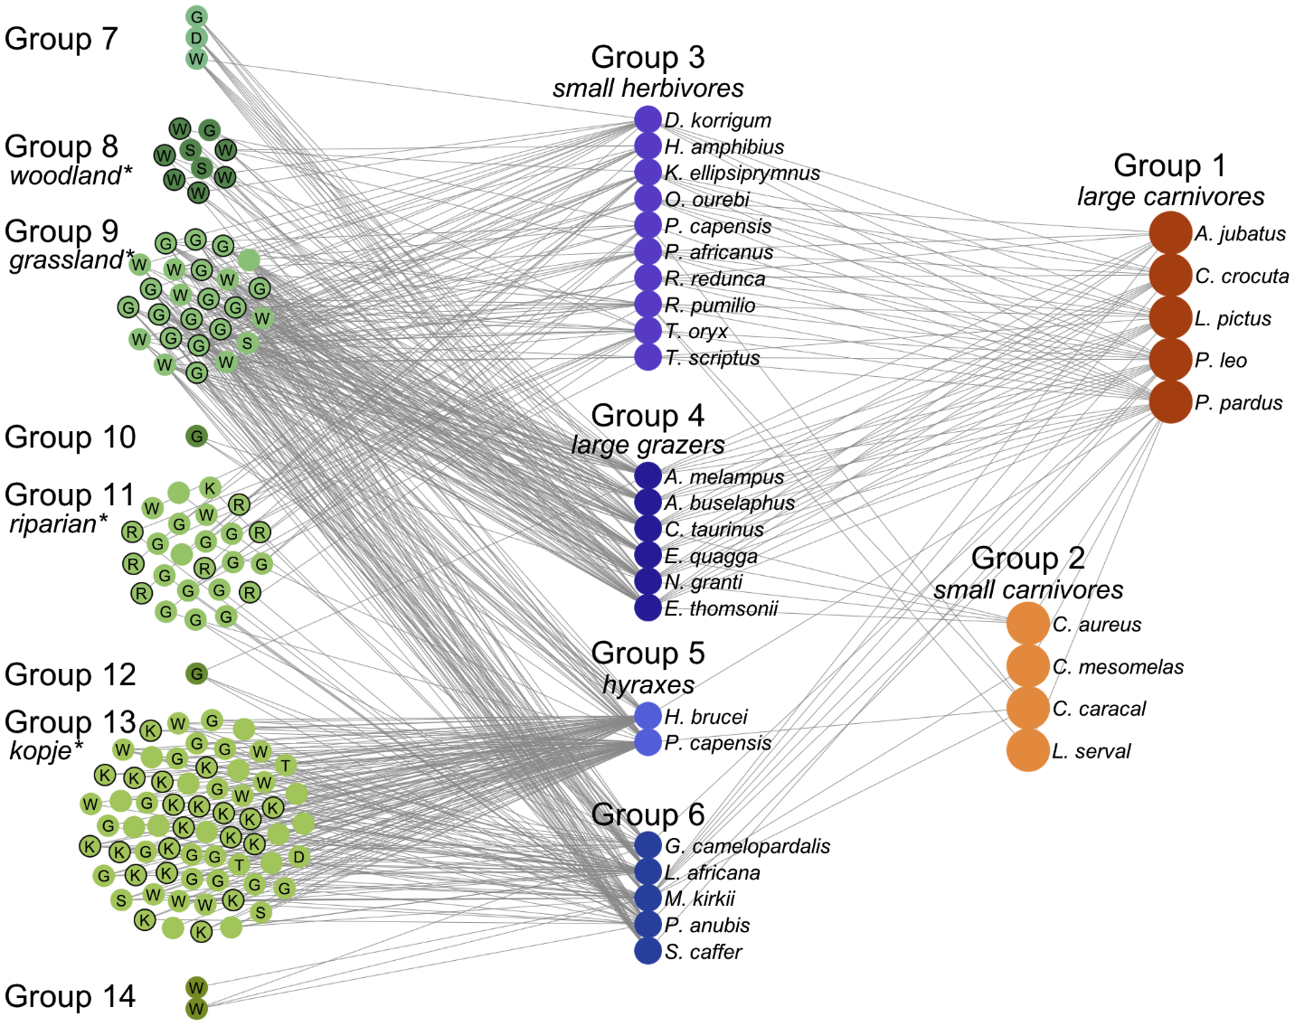
(http://journals.plos.org/ploscompbiol/article/figure/image?size=large&id=info:doi/10.1371/journal.pcbi.1002321.g003)

Top-down control occurs when population size for a higher trophic level influences population size for a lower trophic level. Bottom-up control occurs when the population size of a trophic level is influenced by the rate of production of its food source (or the producers’ population size is influenced by the availability of resources needed for growth). The trophic cascade from wolves to elk to willows (introduced on page 1 and analyzed further on page 4 of the Student Handout) is an example of top-down control of population size. The trends in elk population size were influenced by additional factors, including the very severe winter of 1996-97 when ice over snow prevented access to grass and other forage for elk; this resulted in high elk mortality. This is an example of bottom-up control.

For question 13, the changing availability of taller willows is believed to be one important reason for the changes in number of beaver colonies. The presence of a beaver colony often fosters greater willow growth by raising the water table. Thus, beavers and willows have a mutually beneficial relationship, known as mutualism. The recovery of willows in some parts of Yellowstone, but not in others, appears to be due in part to insufficient soil moisture in many places in the absence of beaver dams. Thus, in order to recover, willows need beavers and beavers need willows; this creates a "catch 22" that appears to have slowed recovery of both willows and beavers after wolves were reintroduced to Yellowstone. Although the Student Handout focuses on trophic cascade effects, the trends in willow growth and number of beaver colonies appear to have been influenced by multiple additional factors (including the release of beavers in a national forest north of Yellowstone and changes in the weather and human hunting) (https://www.nps.gov/yell/learn/nature/elk.htm; http://www.bioone.org/doi/abs/10.3955/046.086.0404).

If you want your students to learn more about trophic cascades and keystone predators, we recommend the video “Some Animals Are More Equal Than Others: Keystone Species and Trophic Cascades” (http://www.hhmi.org/biointeractive/some-animals-are-more-equal-others-keystone-species-and-trophic-cascades).

Recommended Follow-Up Activities
Carbon Cycles and Energy Flow through Ecosystems and the Biosphere
https://serendipstudio.org/exchange/bioactivities/carboncycle
In this analysis and discussion activity, students learn why the biosphere requires a continuous inflow of energy, but does not need an inflow of carbon atoms. Students analyze how the process of photosynthesis illustrates the general principles of conservation of matter and the second Law of Thermodynamics. Then, students analyze how the carbon cycle and energy flow through ecosystems result from photosynthesis, biosynthesis, cellular respiration, and the trophic relationships in food webs. Thus, students learn how important ecological phenomena result from processes at the molecular, cellular and organismal levels.
trophic pyramids

Trophic Pyramids
https://serendipstudio.org/exchange/bioactivities/trophicpyr
Students begin this analysis and discussion activity by thinking about what happens to the atoms in the nearly 2000 pounds of food the average American eats each year. This provides a context for students to figure out why the rate of biomass production is higher for the producers than for the primary consumers in an ecosystem. Then, students construct and analyze trophic pyramids. Finally, they apply what they have learned to understanding why more resources are needed to produce meat than to produce an equivalent amount of plant food.

Both of these activities support the Next Generation Science Standards.

You may also want to encourage your students to research related topics such as:
- aquatic food webs
- eutrophication as an example of bottom-up regulation
- other topics that students may ask about during the activity.

Sources for Figures in Student Handout (Other figures were made by the authors.)
- Trends in wolf and elk populations on page 1 – modified from “Riparian vegetation recovery in Yellowstone: The first two decades after wolf reintroduction” Biological Conservation 198: 93-103, 2016
- Food web on page 3 – http://www.biorewind.com/ecology/

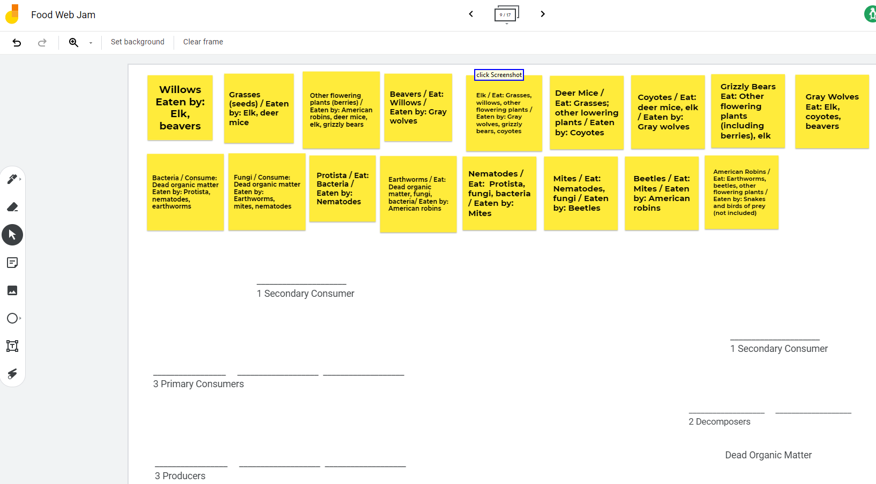
Table for Use with “No Printer” Version of Student Handout

Organism | Eats/Consumes | Eaten by
Willows |  | elk, beavers
Grasses (including seeds) |  | elk, deer mice
Other flowering plants (including berries) |  | American robins, deer mice, elk, grizzly bears
Beavers | willows | gray wolves
Elk | grasses, willows, other flowering plants | gray wolves, grizzly bears, coyotes
Deer mice | grasses, other flowering plants | coyotes
Coyotes | deer mice, elk | gray wolves
Grizzly bears | other flowering plants, elk
Gray wolves | elk, coyotes, beavers
Bacteria | dead organic matter | Protista, nematodes, earthworms
Fungi | dead organic matter | earthworms, mites, nematodes
Protista | bacteria | nematodes
Earthworms | dead organic matter, fungi, bacteria | American robins
Nematodes | Protista, fungi, bacteria | mites
Mites | nematodes, fungi | beetles
Beetles | mites | American robins
American robins | earthworms, beetles, other flowering plants | snakes and birds of prey (not included in this food web)

By Drs. Ingrid Waldron and Lori Spindler, Department of Biology, University of Pennsylvania. © 2021. The Student Handout and these Teacher Preparation Notes are available at https://serendipstudio.org/sci_edu/waldron/#foodweb
Quotations are from http://www.nextgenscience.org/sites/default/files/HS%20LS%20topics%20combined%206.13.13.pdf
We are grateful to Craig Douglas (http://www.douglasanimation.com/) for his help with preparing the cards and the PDF.
To draw a shape - At the top of the page, find and click Shape. - Choose the shape you want to use. - Click and drag on the canvas to draw your shape. To insert text - At the top of the page, click Insert. - To place text inside a box or confined area, click Text Box and drag it to where you want it. - Type your text. - You can select, resize and format the word art or text box, or apply styles like bold or italics to the text. When you are done, click Save and Close.
Student learning is increased when students discuss scientific concepts to develop answers to challenging questions; students who actively contribute to the development of conceptual understanding and question answers gain the most (https://education.asu.edu/sites/default/files/the_role_of_collaborative_interactions_versus_individual_construction_on_students_learning_of_engineering_concepts.pdf).
You may be attracted to the video "Wolves of Yellowstone", but we recommend that you not use this video because many of the statements that are presented as fact in this video are actually quite speculative.
In addition to producers that use sunlight as their energy source, there are producers in deep-sea hydrothermal vents and iron-rich rocks deep below the earth’s surface that use chemical energy contained in compounds such as ammonia or hydrogen sulfide.
American robins belong to both the green and brown food webs. Your students should notice the tiny size of most of the organisms in the brown food web.

